Guide to finding the Snitch and Cassie/Danny

Video guide can be found here:
https://www.youtube.com/watch?v=CJLSh_WlsrU

Last Updated : Y2024 - M03 - D23

Below is a map of some of the Snitch’s possible spawn locations around DC.
Every snitch marker is a place where there has been a confirmed spawn, the pink outline markers are the recommended locations to check as they are near a fast travel point.
There are many more locations as well that are not on this map, this is not a comprehensive list of all positions.

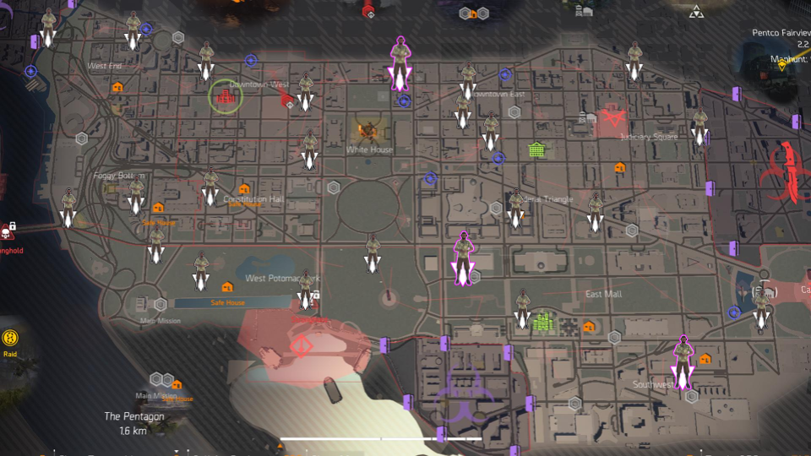

Every time you approach a location, there is a chance that the Snitch will spawn in, so fast travel between the easy spawns till you get him to spawn.
This is also best done right after logging in, as there is a cooldown to him as well, and you may unintentionally trigger it while in missions, control points, bounties, etc.
And once it is triggered with him spawning in, even if you do not find/interact with him, he will not spawn again for 60 minutes.

Once you have found the snitch and interacted with him, the locations of Cassie Mendoza & Danny Weaver will be put on your map. The bounty you receive is completely optional and not required to reveal them.

Upon Hovering over their marker you can already see if they will be open or closed, a sit shows that in the upper left corner as such.


Cassie & Danny are open for 24 hours and then closes and repositions for 32 hours, starting on wednesdays at loot reset.
That cycle means that they can be said to be available for these CET times: wednesday, late friday +early saturday, and late sunday + most of monday. As outlined below in this sheet based on CET time.
Time in 8 hour chunks | wednesday | thursday | friday | saturday | sunday | monday | tuesday
0900 CET (daily reset) | open | closed | closed | open | closed | open | closed
1700 CET | open | closed | open | closed | closed | open | closed
0100 CET | open | closed | open | closed | open | closed | closed
Their inventories change once a week with all the other vendors on tuesday’s weekly vendor reset, but they won't be available till wednesday.

The reset time can be found for your timezone by toggling targeted loot in the map screen, and at the bottom it will state time till the next daily reset.


Or by converting the CET time to your local time with a google search.

Links to my other guides, the Build Collection, DMG/DPS Calculators and many other things:

https://docs.google.com/document/d/15mg-_sjowh5_8bUp2VIBqnDxCDqz-xJOISl0DlG3RDU

